Julian Kotara
Sandra Vasconez
Landscape and Exterior Lighting
24 August 2026

In the era of electric lighting, one useful ability of LEDs is to allow the illumination of our streets and parks at night, allowing extended activity time far into the nights. However, while this allows for harmless activities like walking one’s dog or a late-night run to be possible, it also allows for crimes and ill-intentioned activities to take place after the sun has gone down as well. While the current solutions are far more elegant than the lighting towers from the late 1800’s and improve the amount of light from London neighborhoods with their gas-powered lamps, the harsh LEDs still cause discomfort to drivers and don’t stop nighttime crimes from occurring.
Crime occurs in cities across the globes with many varying factors that include politics, wealth, culture, and policing, making it difficult to pinpoint where exactly night light can improve. For a long time, much of research has concluded that more lighting means safer streets, but these findings are not always corroborated from paper to paper. From some light skimming, many of the papers from the late 70s to early 2000’s only compares either nighttime crime levels to daytime crime levels and then add some light, or they compare two different areas; one with more light and one with less light. Due to the limited scope of this research, I believe they fail to truly capture the effect of light on the area as there were questions left unanswered; Did crime just move to a different street? Was there more daytime crime? What happened after the experiment ended?
In newer research, types of crimes and past criminal events have been more closely studied with a clear trend that seems to emerge. When more light is present, property crimes (car theft and home burglary’s) seem to decrease, hinting at an environmental factor to these crimes. If it is darker, it feels plausible that breaking into a home or a car will attract less attention and it remains easier to stay hidden. Violent crimes (assaults and shootings) did not seem to be generally affected by lighting changes as the surrounding environment likely has a smaller effect on the crime occurring. In the images below, Nick Mesler presents his research during a webinar hosted by USCPTED. Comparing Pittsburgh and Santa Ana, he found similar trends regarding crime occurrence and light levels at those locations where the crime occurred.

Assault crimes – falls more significantly with more light
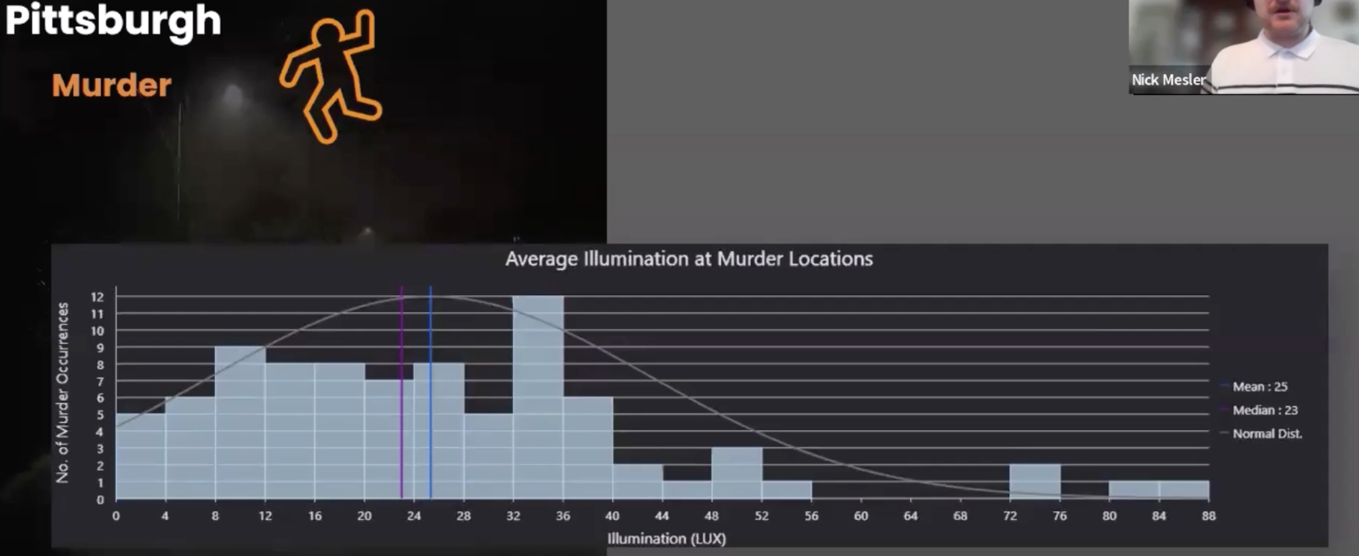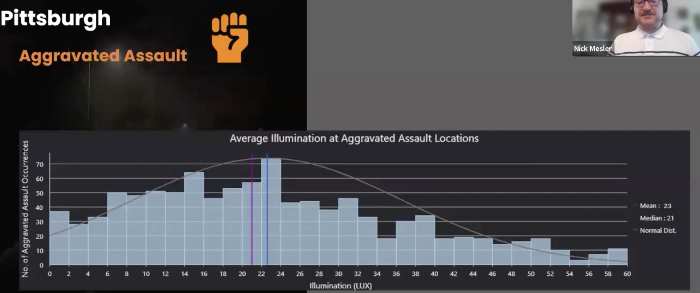

Theft crimes – falls less significantly with more light
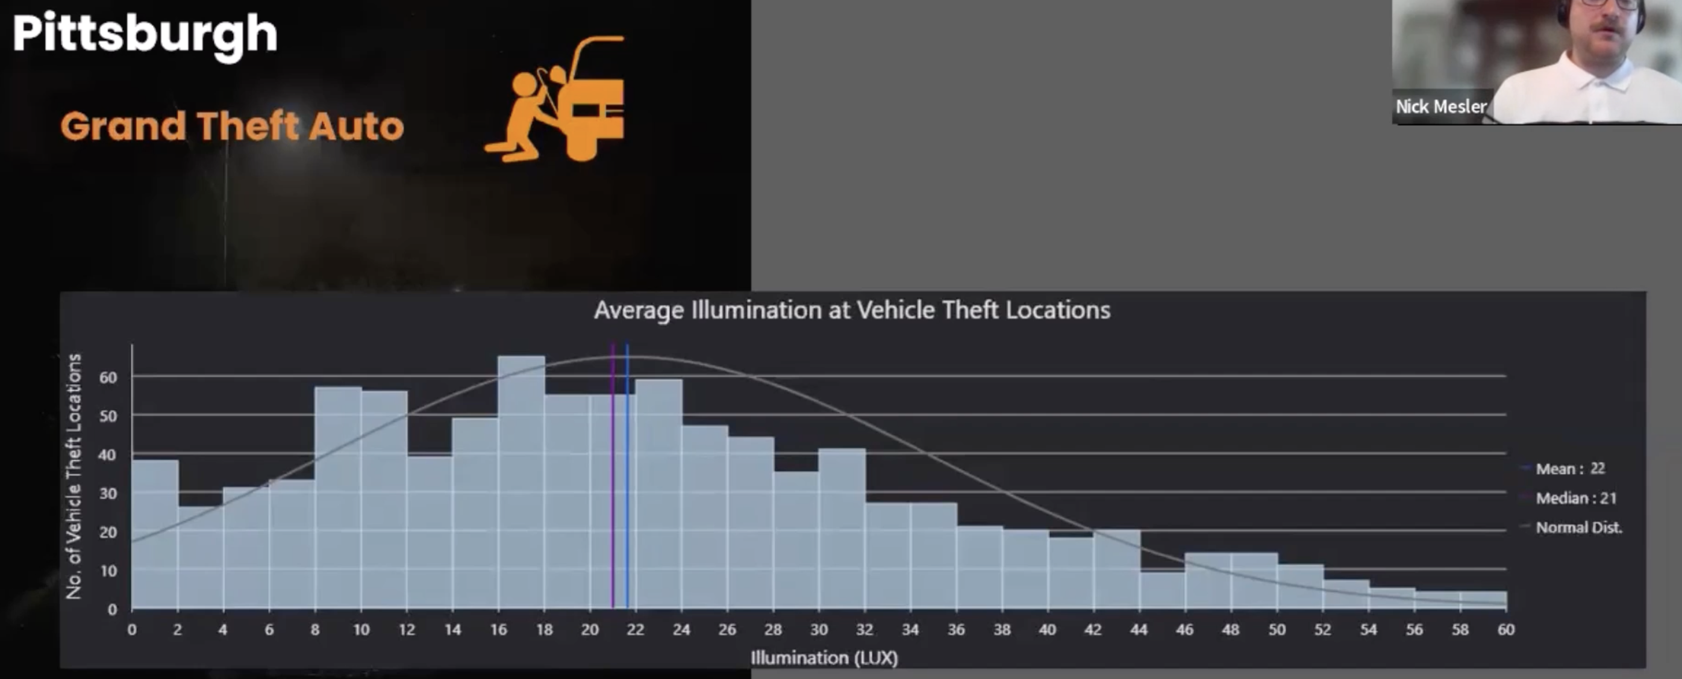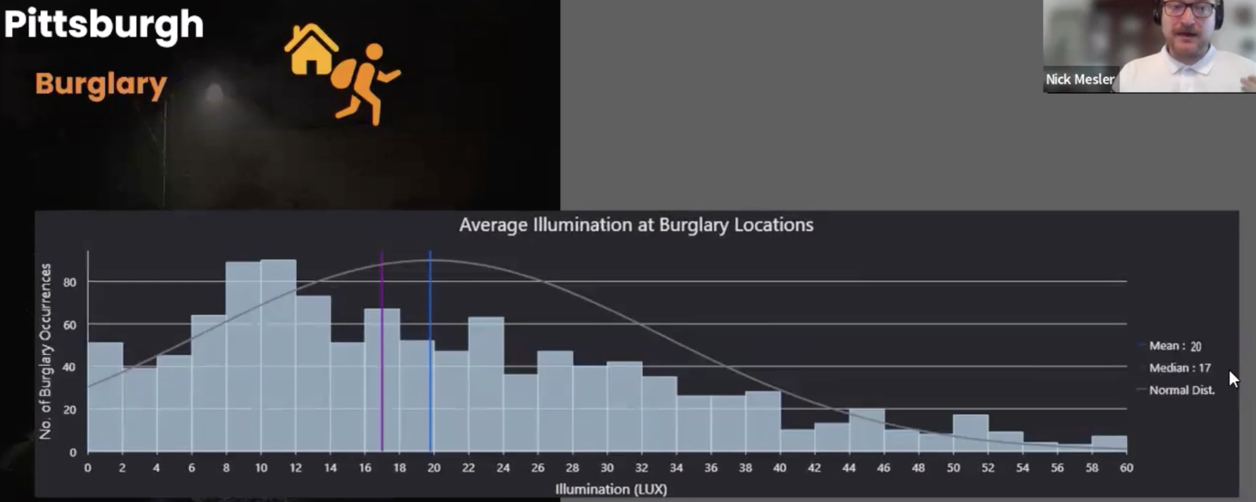

While the implementation of exterior lighting has certainly aided in safety across the world, there are still improvements to be made. While more light is generally better, other metrics such as glare, illuminance ratios, CCT, and direction of light can affect how people feel and act in exterior spaces. Since human psychology is difficult to understand, and its illogical to force crimes to happen when research is occurring, there might not be a conclusive answer this problem.

